Open access article
RESEARCH ARTICLE

Sample Ruhuna Journal Paper (Topic / Title of the Paper)

FA FirstAuthor¹*, SA SecondAuthor²
¹ Institute Name1, Address, City, Country
² Institute Name2, Address, City, Country

Abstract: This document gives formatting instructions for authors preparing papers for publication in the Ruhuna Journal. The authors must follow the instructions given in the document for the papers to be published. You can use this document as both an instruction set and as a template into which you can type your own text. Author details and affiliation information should be removed from the manuscript in the initial submission. Abstract should not exceed 250 words and no references to articles, equations, diagrams, etc. This should only include a summary of objective(s), methodology and important results/conclusions and should be written in one paragraph.

Keywords: Include a minimum of six (6) most appropriate keywords or phrases.

Introduction

This document is a template. An electronic copy can be downloaded from the journal website. For questions on paper guidelines, please contact the editorial board as indicated on the journal website. Information about final paper submission is available from the journal website.

Introduction section should include a brief description of the reasons for conducting the study including the background. References to any previous work related to the study by the same author or any other authors should be included. Give reference to any conference presentation (oral or poster) of the same or the part of the work given in the paper (with the titles and the name of the conference/meeting in the reference section).

Paper Layout

An easy way to comply with the journal paper formatting requirements is to use this document as a template and simply type your text into it.

Page Layout

Your paper must be typewritten using double-spaced text of Times New Roman 12 font throughout on one side of A4 size paper, leaving at least 1.25 inch margins on both sides and 1 inch margin on top and bottom with proper numbering of pages.

Paper Structure

The layout of the manuscript should be as followed.
- Introduction
- Materials and Methods
- Results and Discussion
- Conclusion

In addition, Acknowledgement can be given. It should be brief and made for specific scientific and technical assistance only and not for routine help in preparing manuscripts. If a significant part of the research was performed in an institution other than in those indicated by the authors’ affiliations given in the title page, this fact should be acknowledged.

Text Font of Entire Document

The entire document should be in Times New Roman or Times font. Recommended font sizes are shown in Table 1.

Figures and Tables

Figures and tables must be centered in the column as shown in Fig. 1. Large figures and tables may span across both columns.

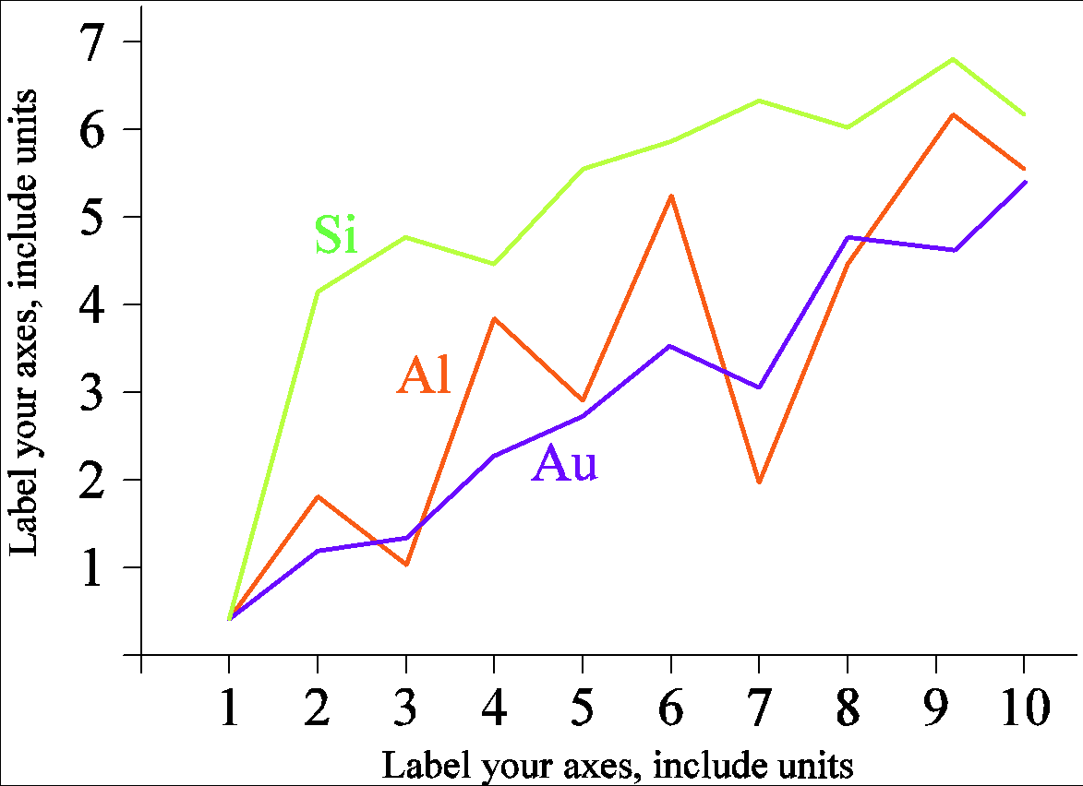
Figure. 1 A sample line graph using colors which contrast well both on screen and on a black-and-white hardcopy

Referencing Style

References to the literature must be indicated in the text and tables as per the APA seventh edition referencing/citations style (Bradley et al., 2020). All reference items must be in 10 pt font.

Materials and Methods

Materials and Methods section should detail how the study was carried out and should include complete description of any new methods/procedures. If an already established method or methods followed, proper reference(s) should be given. Methods of statistical analysis should be stated appropriately. Any sketches/diagrams relevant to study methods/procedures could be given as relevant.

Results and Discussion

The results should be presented briefly, but clearly and rationally. Only the data essential for the main conclusions should be included, in tabular form, whenever possible. Interpretation of data with proper discussion needs to be included here. Repetition of the same results in figures, tables or text should be avoided. Statements that are not supported by data should be avoided. Tedious discussions should be avoided. Tables, figures, etc. should be attached to the end of the manuscript, after references with proper numbering.

Table 1: Font Sizes for the Paper
Font Size | Appearance (in Time New Roman or Times)
 | Regular | Bold | Italic
10 | abstract body, table content, paragraphs, references | abstract heading, Level II headings, table captions | keywords
12 |  | Level I headings
14 |  | title

Conclusion

All new conclusions drawn should be included here. If earlier findings or conclusions get revised, proper references should be given.

Acknowledgement

The heading of the Acknowledgment section and the References section must not be numbered.

Reference

Bradley, L., Noble, N., & Hendricks, B. (2020). The APA Publication Manual: Changes in the seventh edition. The Family Journal, 28(2), 126-130.

