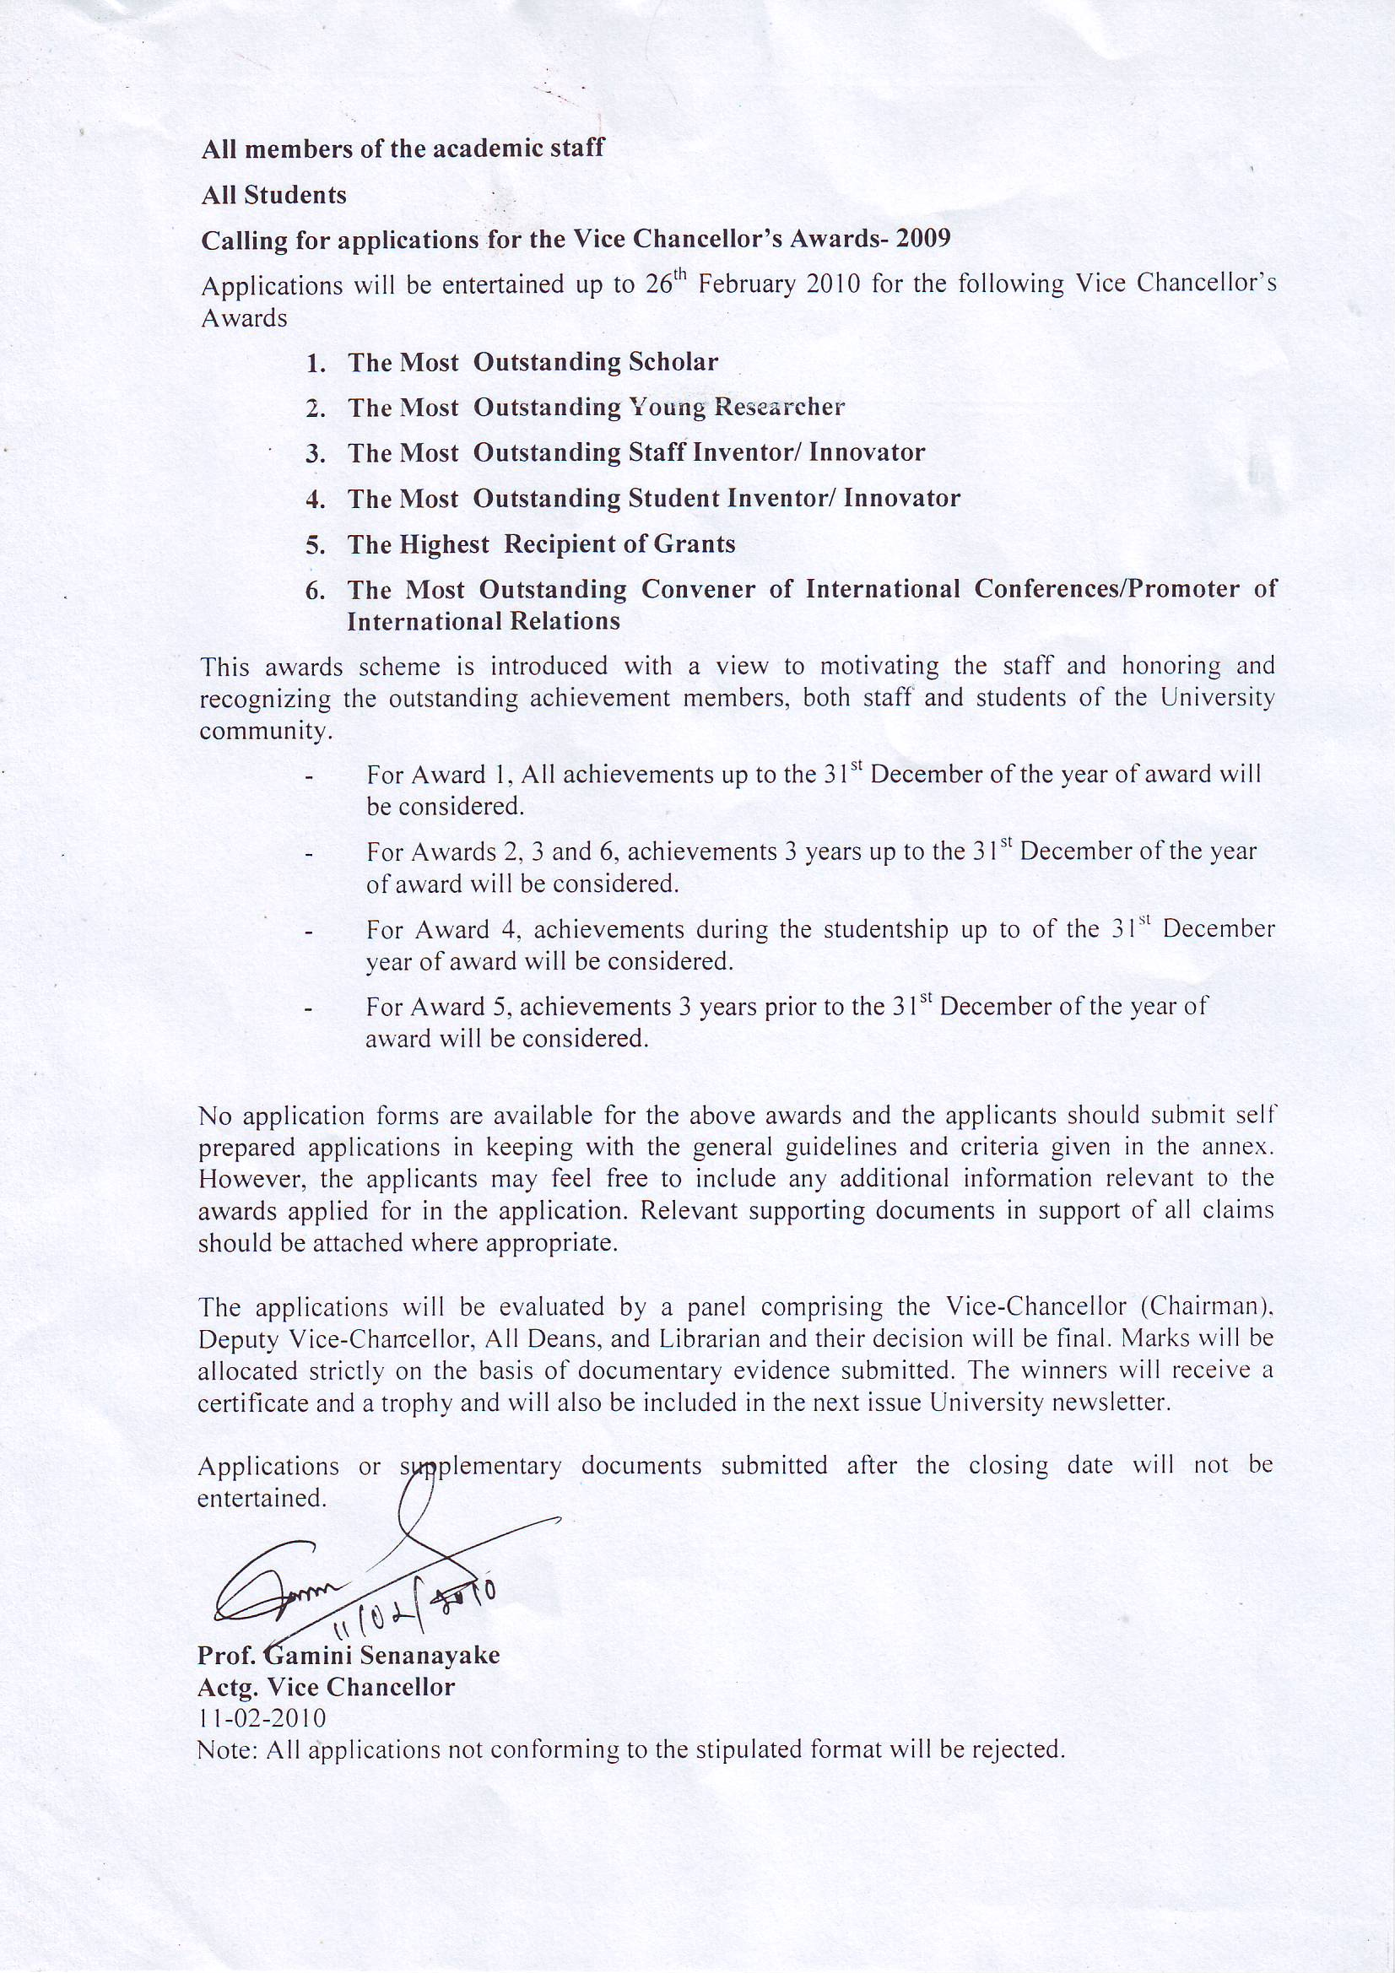

VC AWARDS SCHEME 2009 The Most Outstanding Scholar
- A minimum of 80 points should be obtained for a teacher to be eligible to apply.
- Applications by the candidates should be forwarded to the Vice Chancellor through normal channels.
- The applicant can submit achievements accumulated up to the 31st December of the year of award.
- Eligible be award winner only once

Component | Marking scheme | Marks claimed  by the  applicant | Marks given  by the  evaluators
a. Publications
(i) Publications in refereed indexed | up to 5 points each
journals. If two authors first author
will be given 60 and the balance will be
given to the second author. If over two
authors 40% given for first author and
the balance will be equally dived by the
rest of the authors.
(ii) Publications in refereed | up to 3 points each
non-indexed journals ( Same
conditions as per the refereed indexed
journals )
b. Presentations at conferences/
professional meetings etc.
(i) Published as an abstract ( Marks will | up to 0.5 points each
be divided as per the journal articles
when number of authors are more than
one)
(ii) Published as a full paper (Marks | up to 2 points each
will be divided as per the journal
articles when number of authors are
more than one )

c. Chapters in books published by  (i) Internationally recognized publisher  (ii) recognized scientific, academic or  professional bodies | up to 4 points each  up to 2 points each
d. Books and/or textbooks published  in the area of expertise of the  applicant  (i)A recognized international publisher  ₋  The author ( Information on number  of copies published, ISBN, level (for  School children , University students etc ),  Number of pages (minimum 50 pages) | up to 6 points each  if reviewed by two  experts up to 4 points,  if it is not up to 2 points | .
(iii) Booklets – less than 50 pages | up to 2 points
(iv) Monographs | up to 3 points
e. Translation of monographs/ books | up to 3 points each
f. Editing of journals/books  (i) as Editor-in-Chief in refereed  journals  (ii) as a member of editorial  board of refereed journals | 0.5 points per issue  up to a maximum of  5 points per journal  0.25 points per issue  up to a maximum of  2.5 points per journal  -  2 points per book
g. Documented orations, keynote  addresses etc. in recognized  national or international  Professional bodies.  i Orations  • International  • National  • Local  (text of oration should be submitted) | 5 points  3 points  0.5 points

ii Keynote addresses/presidential  addresses | 02 points per event  up to maximum of 10
h. Citation of applicant's work in | 0.5 point up to a
refereed journals and scholarly | maximum of 6 points
publications (excluding self- | for repeated citation
citations) | per paper
L Recognized national/international  meritorious awards for research  and creative work | up to 3 points each
j. Creative work* | up to 3 points each
k. For each grant  i Funds received from international | 1 point per US$2,500
sources | or its equivalent
ii Funds received from national | 1 point per Rs.
sources | 250,000  up to 10 marks
(% within the
applicants. Highest
recipient gets full
marks of 10. Others
proportionately.)
1. Number of graduate | up to 2 points per
students supervised and  graduated** | PhD  up to 1 point per
MD/MS students***
and MPhil or Masters
by research of 2 or
more years duration
up to 0.5 point per
Masters of 1 or more
year duration with a
research component
up to a maximum of
 | 10 points

- In regard to poems, songs, novels etc. composed and dances, plays, films etc. produced, reviews or appreciations by authoritative persons should be attached in respect of each item. In regard to a creative product or service in science or allied field, a brief description on the creative nature of the item should be submitted along with documentary proof. With regard to specific work of international reputation justification should be made.
** It should be sated whether served as the principal supervisor or as a co-supervisor. The principal supervisor is given full marks while the co-supervisor, 50%. Student should have graduated prior to the dead line of application.
*** In case of MD /MS students suitable fraction out of the maximum marks will be allocated based on the number of trainers

2. The Most Outstanding Young Researcher
- A minimum of 35 points should be obtained for a teacher to be eligible to apply.
- Applications by the candidates should be forwarded to the Vice Chancellor through normal channels.
- The applicant can submit points accumulated up to the 31st December of the year of award.
- Only those who are less than 40 years on the closing date of the application are eligible to apply
- Eligible be award winner only once

Criteria are similar to those of the Most Outstanding Scholar Award.

Component | Marking scheme | Marks claimed  by the  applicant | Marks given  by the  evaluators
a. PhD | 05 points for each
b. M Phil | 03 points for each
c. MA/MSc | 02 points for each
d. Additional Bachelor Degree | 1.5 points for each
e. Postgraduate Diploma | 01 point for each

3. The Most Outstanding Staff Inventor/Innovator

- A minimum of 6 points are required to be eligible to apply.
- Include achievements within 3 years prior to the 31st December of the year of award.
- once the person is received the title, He /She has to earn fresh marks if to apply for the same award in a subsequent occasion
- Applications by the candidates should be forwarded to the Vice Chancellor through normal channels.

Component | Marking scheme | Marks claimed  by the  applicant | Marks given  by the  evaluators
a. National and international | up to 3 points each
patents | (national)  up to 5 points each
 | (international)
b. National and international | up to 1 point each
certificates for invention | (national)  up to 2 points each
 | (international)
c. Industrial designs | up to 3 points each
( International )
up to 2 points each
 | ( national )
d. Commercialized patents* | up to 5 points each

*A brief description should be given on the number of machines/implements/ instruments assembled/produced are sold, quantity of product produced and marketed, software developed and sold, type of biological or chemical process invented, and the impact on any particular sector, industry or community and contribution to regional/ national development.

4. The Most Outstanding Student Inventor/Innovator

- The point scheme is the same as for the staff.
- The minimum requirement to be eligible to apply is to have evidence of inventions.
- Achievements any time during the studentship up to 31st December of the year of award are acceptable.
- An applicant is entitled to submit an application yearly.
- Students who have completed the degree during the year of award are also eligible to apply. Their achievements should be dated prior to completion of degree.
- Applications by the candidates should be forwarded to the Vice Chancellor through normal channels.
- Any special achievement under this category with proven evidence will be awarded up to 05 points
5. The Highest Recipient of Grants
- A minimum of 10 points are required to be eligible to apply.
- Include all the grants received within 3 years prior to the 31st December of the year of award.
- once the person is received the title, He /She has to earn fresh marks if to apply for the same award in a subsequent occasion
- Applications by the candidates should be forwarded to the Vice Chancellor through normal channels.

Component | Marking scheme | Marks claimed  by the  applicant | Marks given  by the  evaluators
a. Funds received from  international sources | 1 point per  US$ 2,500 or its  equivalent
b. Funds received from national  sources | 1 point per  Rs. 250,000

A brief description should be given on the outcome including capacity building, staff training, improvement of laboratory facilities and research capabilities, establishment of new units, centers, etc.
This should be certified by the Head of Department and the Dean of the Faculty concerned.

6. The Most Outstanding Convener of International Conferences/ Promoter of International Relations
- A minimum of 10 points are required to be eligible to apply.
- once the person is received the title, He /She has to earn fresh marks if to apply for the same award in a subsequent occasion
- Include all achievements within 03 years prior to 31st December of the year of award
- Applications by the candidates should be forwarded to the Vice Chancellor through normal channels.
- Once in a life time award.
International Conferences

Documentary evidence should be submitted by the applicant. No .of sessions
No. of Guest speakers local foreign
Funds received
Benefits for the University and the Nation
International Relations
Documentary evidence should be submitted by the applicant Funds received
Duration of the project
Benefits/Advantages for the Institution
Contribution for national development

Component | Marking scheme | Marks claimed  by the  applicant | Marks given  by the  evaluators
a. International events
organized including
conferences, workshops,
training programmers,
symposia *
No. of sessions | 2 point per session
(Session – minimum 03 hrs)

b. Link programmes,
collaborative research  projects MOU  developed** | Maximum up to 18 points
Editing of proceeding | 5.0 point
Link Programme | 2.5 point per link programme
(i) No. of short-term  foreign training arranged | 1.5 points/person trained
(ii) No. of academic visits  made internationally. | 0.5 points/visit
(iii) No. of staff served as  resource persons in a  foreign institution | 1.5 points/ resource person
(iv) No. of overseas | 3 points each
Masters scholarships
obtained
(v) No. of overseas  doctoral scholarships  obtained | 5 points each
(vi) No. of students | up to 5 points per project
exchanged | depending on the number of  students, duration of the visits  etc.
(vii) Outcome of research | up to 5 points per project
projects | on the number of research  publications, monographs,  Innovations, inventions etc.  produced

* 50 % of the total marks for an event calculated on the above basis are given to the Chairman of the Organizing Committee while a member of the organizing committee is given a part of the remaining 50 % depending on the number of members in the organizing committee.
**A brief description on contribution to capacity building and institutional, regional/national development should be provided along with relevant supporting documents.
This should be certified by the Head of Department and the Dean of the Faculty concerned.

